Proper Steps to Taking an X-Ray
------------------------------------------
- BEFORE YOU LOG IN insert the sensor
- Log into the computer but DO NOT OPEN ANY SOFTWARE YET
- Wait a few seconds for this bubble in the bottom right corner to pop up:
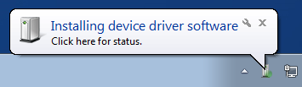
- A few seconds later another bubble will appear…
Schick:
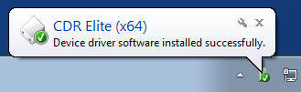
Kodak:
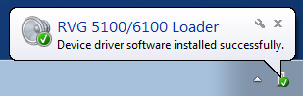
- Launch axiUm/MiPACS
If you are still experiencing issues after following the steps above, please call IT at 215-898-8957! Thank you!

